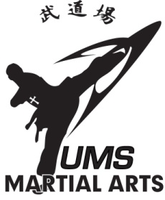
2026 UMS Martial Arts
SUMMER CAMP

6343 Columbia Pike, Falls Church VA 22041 / 703-914-1110

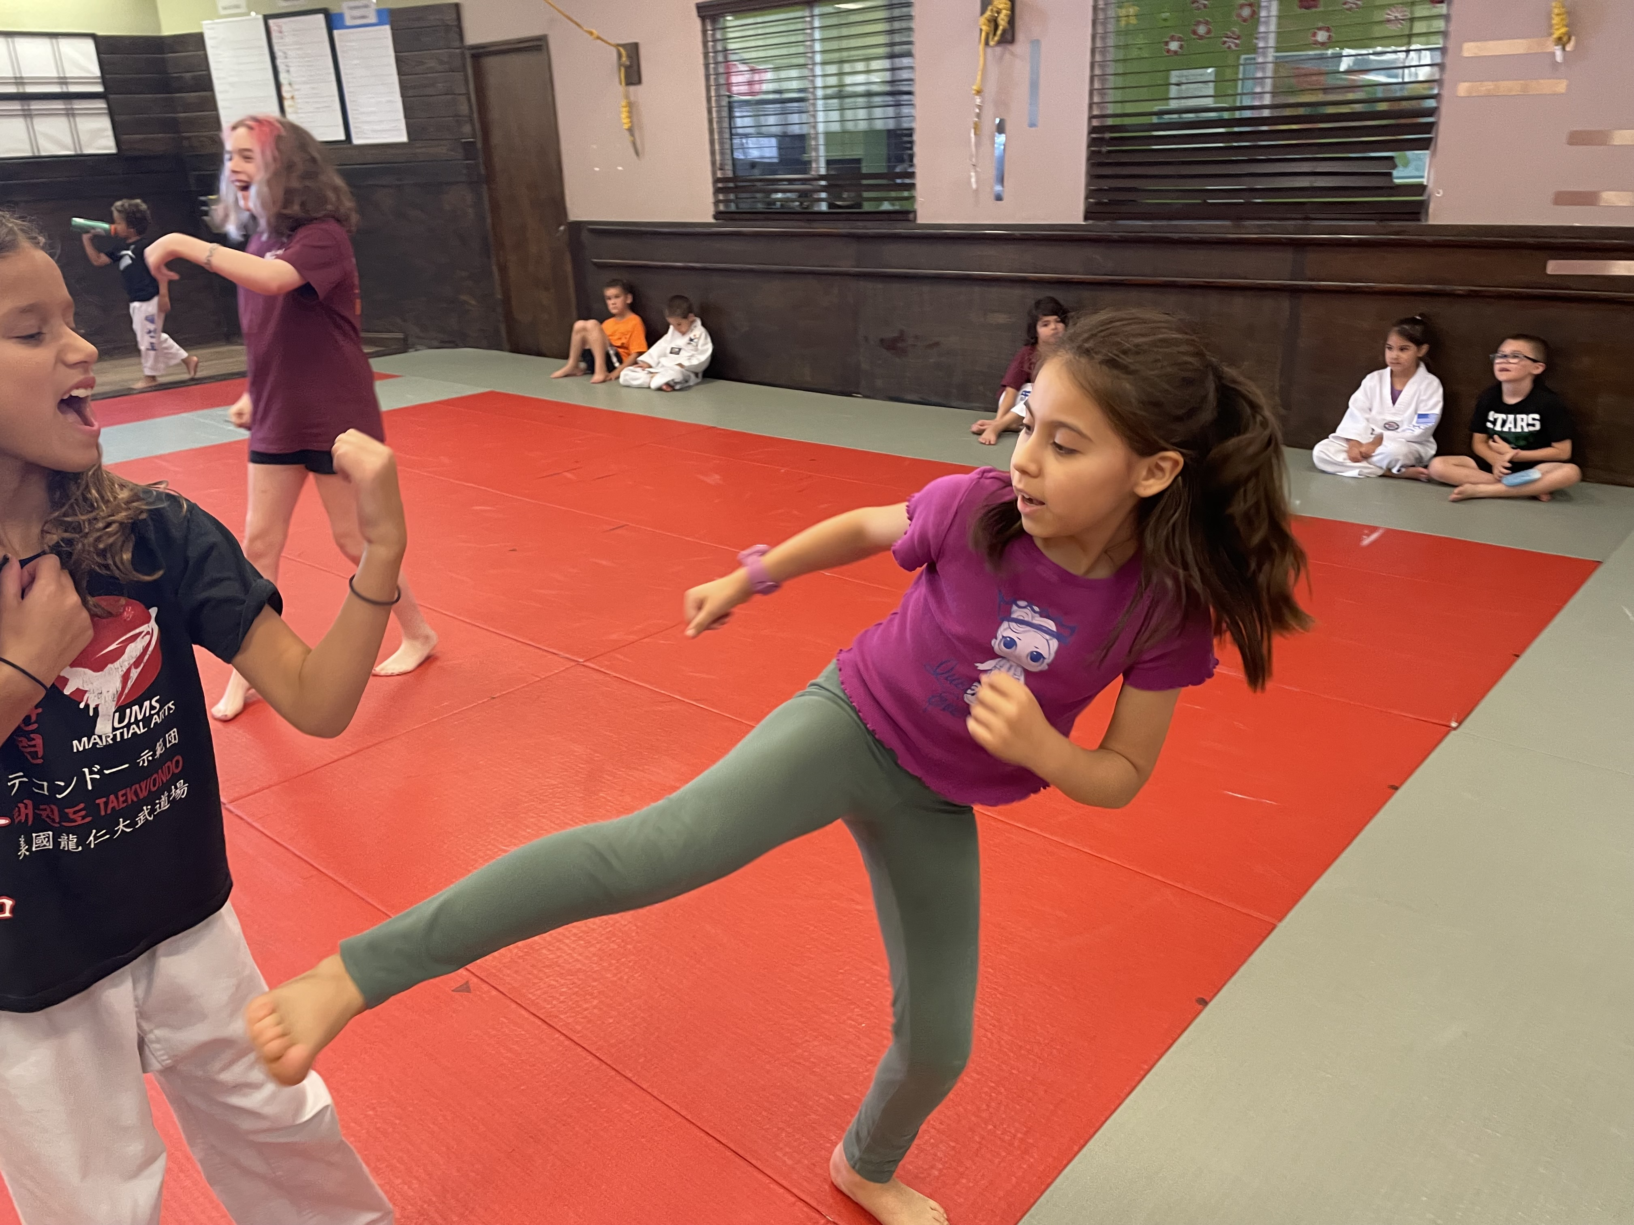
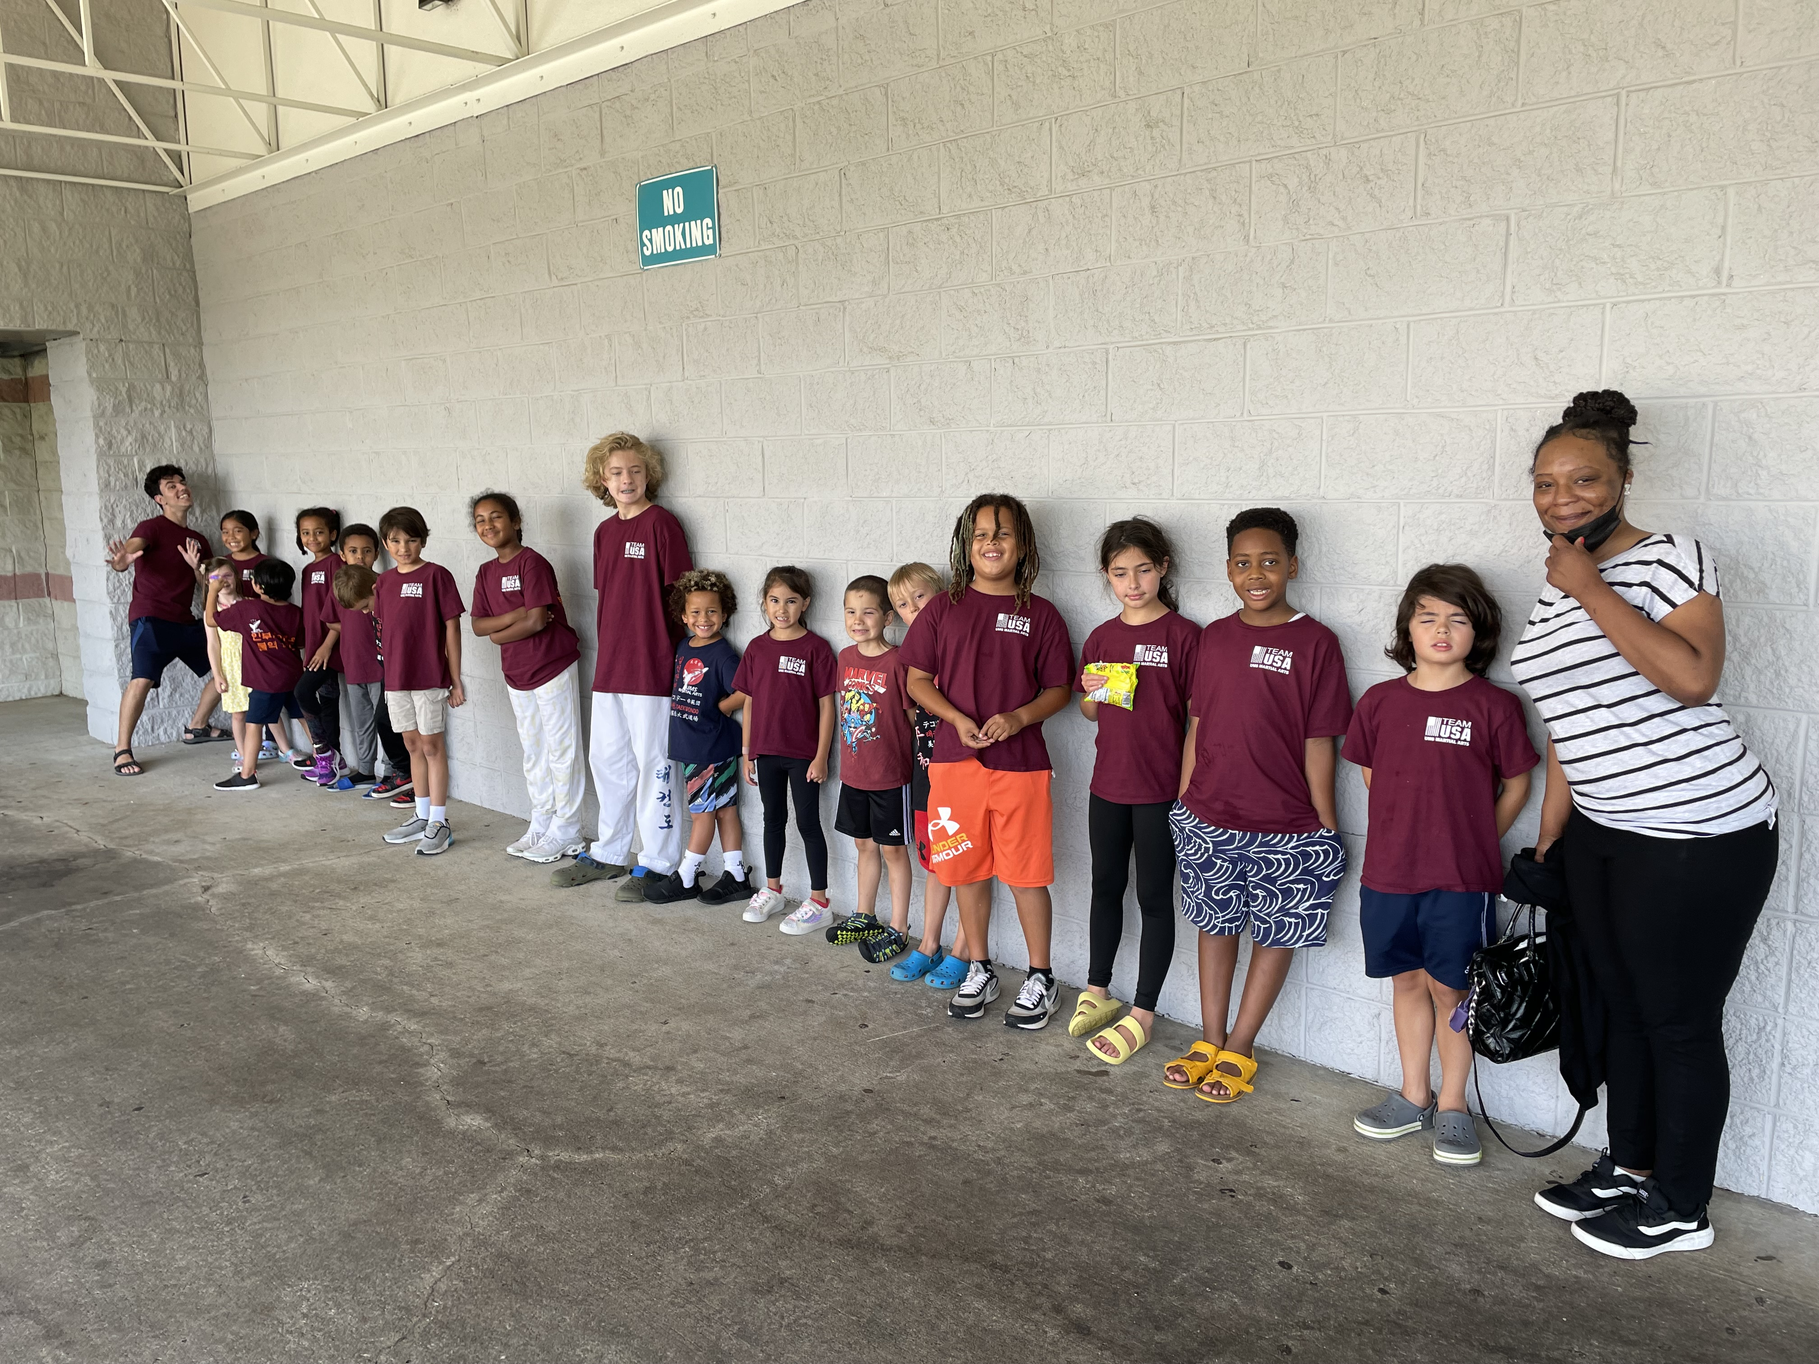

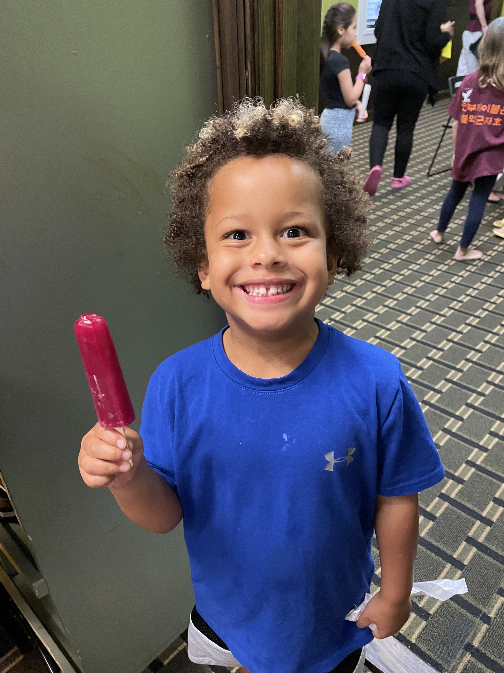

- Dates: June 16th – August 15th
- Hours 7:30am – 5pm ($8 per extra hour after 4:30pm)
- $319 a week / Free Uniform 4 weeks & more
/ $10 off for additional family members /
- Registration Fee $40 (include one Camp T-shirt)
Taekwondo Uniform $70,
- Who can attend: 5- to 12-year-old students
- years & up need special permission from Grand Master Um)
- Taekwondo, Discipline, Self-confidence, Focus, Exercise… more

* The Korean embassy is requiring a reservation. We will announce as soon as the reservations are confirmed
Camp Includes: Taekwondo classes, Korean Embassy, Swimming pool, Flower Garden, Laser tag in studio, Bounce house in studio, Parks, Movies in studio, Sports, Korean Language etc. ….
Field Trip Fee will apply for: Chuck E. Cheese, Movie Theater


Visit our site umsKICK.com umsmartialarts@gamil.com
Any questions? Text/call 703-914-1110

M O N
8:30  am | Kiss & Ride between 8:30 – 9:45 am.  Play quiet activities, games, movie.
9:40  am | The camp begins! Dojang rules;  Learn mannerism. Martial Arts  1 wk. Sword 2wk. Nun Chuk 3wk. Kickboxing  4 wk. Sword 5wk. Nun Chuk 6wk Kickboxing  7wk Sword 8wk. Nun Chuk
11:30  Am | Lunch & rest; Supervised free time.  Board games, Legos, blocks.
12:50  pm | Swords responsible with obstacle course  Dodge ball, Music sparring with no contact,  Learning organization, Discipline exercise
3:15  PM | Taekwondo meditation clean-up  Responsibility and snack time
 | T U E
8:30  am | Kiss & Ride between 8:30 – 9:40 am.  Play quiet activities, games, movie.
9:45  am | Sword Class: Sword tech and punching practice,  Target striking, Dummy bag striking,  Combination tech.
11:00  AM | Lunch & go to the Field Trip  Week 1. Sword tech. Korean Embassy  Week 2. Nun Chuck. Laser tag in studio  Week 3. Kickboxing, Chuck E cheese  Week 4. Sword tech, Movie Theatre  Week 5. Nun Chuck, Chuck E Cheese  Week 6. Kickboxing, Korean Embassy  Week 7. Sword tech, Laser Tag in stuido  Week 8. Nun Chuck, Chuck E Cheese  Week 9. Kickboxing, Bounce House
2:45 PM | Return to the dojang, Taekwondo meditation  and stretch, learn to organize & clean-up  Responsibility and snack time
3:45 | Camp ends: Quiet-activity until parents pick up

W E D
8:30 | Kiss & Ride between 8:30 – 9:40 am.  Play quiet activities, games, or watch a movie.
9:40  aM | TKD Class: One-step sparring & free sparring  Posture and movement. Combination steps
11:00  Am | Lunch & rest; Supervised free time  Board games, Legos, blocks….
3:15  PM | Taekwondo discipline and meditation,  Learning organization & clean-up responsibility  and snack time
3:45 | Camp ends: Quiet-activity until parents pick up

T H U R
8:30  am | Kiss & Ride between 8:30 – 9:40 am.  Quiet-time activities, games, or movie.
9:40  am | Taekwondo self-defense training and  Obstacle courses. Spider punch and kick!
11:00 | Lunch Time & go to the Swimming Pool
2:45 | Return to the Dojang, Meditation  Taekwondo discipline – learn to organize  & clean-up; Responsibility and snack time.
3:45 | Camp ends- Quiet activity until parents pick up
F R I
8:30 am | Kiss & Ride between 8:30 – 9:40 am.  Play quiet activities, games, or watch a movie.
9:40 Am | Taekwondo: Practice breaking techniques, and  Movie style sparring. Obstacle course
11:30  AM | Lunch Time & rest; supervised time:  Game day!
1:00 | Taekwondo Board Breaking Techniques
3:15  PM | Taekwondo discipline – learn to organize &  clean-up; Responsibility and snack time
3:45PM | Camp ends: Quiet-time activity  until parents pick up  - Schedule is subject to change.  - Bring own Lunch and Snacks every day.  - On Chuck E Cheese field trip days, lunch is provided. (only bring snacks)  - Not allowed to bring any kind of nuts.  - Mon. & Fri. – wear uniform  - Tue. and Thur. – Camp T-shirt  - Thursday – Swim suit and sun screen
2026 Summer camp schedule
2023 UMS Summer Camp Registration Form
Guardian Name: |  | Email:
Address:
Home Phone: | Work Phone: |  | Cell Phone:
Emergency Contact Name: |  | Relation to student:
Phone:
Student 1: |  |  | Age: | Gender: M or F
Student 2: |  |  | Age: | Gender: M or F
Student 3: |  |  | Age: | Gender: M or F
Any health conditions to be aware of?
2026 Summer camp Registration forms

1 | 2 | 3 | 4 | 5 | 6 | 7 | 8 | 9
6/16 - 20 | 6/23 - 27 | 6/30 – 7/4 | 7/7 - 11 | 7/14 - 18 | 7/21 – 25 | 7/28 – 8/1 | 8/4 - 8 | 8/11-15
Pd._____  Korean Embassy  Sword | Pd._____  Laser tag in studio  Nun Chuk | Pd. _  Chuck E cheese  Kickboxing | Pd. _  Movie Theatre  Sword | Pd. _  Chuck E cheese  Nun-chuk | Pd. _  Korean Embassy  Kickboxing | Pd._____ Laser tag in studio  Sword | Pd._____  Chuck E Cheese  Nun Chuk | Pd._____  Bouncy House and Kickboxing
*Camp hours: 7:30am – 5pm *Camp fee: $319 a week ($8 per extra hour care after 4:30pm)
$10 discount for additional family members / Free Uniform for signing up for 4 weeks or more
$50 Deposit is required each student to hold your spot for each week. It is not refundable.
$40 Registration Fee will include UMS Camp T-Shirt. $60 Taekwondo Uniform (if already have it don’t buy again)
*4 weeks & more, camper receives 2 T-shirts. *1~3 weeks camper receives 1 T–shirt.
If paying weekly, the Camp fee will be charged on Friday (10 days before.)
Field Trip: Chuck E Cheese $40(include Tokens), Movie Theater $30 (include popcorn & drink)

Registration fee: Deposit:
INITIALS
$ ck CC Pd On: / / |

CK CC CA Pd On: / / |

Credit Card: *requires

Exp. Date: / CVS code: .
We will charge every Friday 10days before camp start

- TKD Uniform: Camp T shirts:
- Sword $35: Nun Chuk $25:
- Kickboxing Glove $25:

CALCULATIONS & PAYMENT:

Camper 1 X = $
WEEKLY RATE # OF WEEKS

Camper 2 X = $
10% OFF WEEKLY RATE # OF WEEKS

Camper 3 X = $
10% OFF WEEKLY RATE # OF WEEKS

TOTAL $

TERMS OF AGREEMENT

Payment//Modification Policy: Registration payment reserves the camper(s) listed above space in the camp. All payments are non-refundable. Payment for the week secures the entire week, even if the camper(s) listed above does not attend the entire week. If payments are not received on time the camper(s) will not be allowed in the camp. Payments made weekly will be due 10 days before the start of the week (Friday). Failure to make a payment on any due date (whether in person or due to rejected Credit Card draft) will cancel participant’s registration. If the payment (i.e. card or check) is found to be declined on the due date, there will be a $15 decline fee.

I understand that due to limited space, there is no guarantee that chosen camp weeks that the student(s) attends can be changed.
The camp schedule is subject to change depending on given circumstances.

If the camper(s) cannot attend due to physical reasons (i.e., broken leg), a doctor’s medical note must be provided in order for payments to be applied toward future camps or Taekwondo memberships.
A $25 service fee made payable to UMS Martial Arts will be charged for bounced checks. A $25 service fee is charged for modification of weeks (not for adding weeks in advance). $8 will be charged per extra hour spent at the camp after 4:30. Failure to make payments will result in referral to a collection agency.

Waiver and Release: I, as the child(ren)’s legal guardian, fully recognize that martial arts involve strenuous physical exercise and I am fully aware of the risks of injury and/or illness inherent in participation in any fitness or martial arts program, and I have taken all reasonable steps to determine, and hereby warrant, that my child(ren) is(are) in good health and physically capable of participating in the programs and courses of instruction offered by UMS Martial Arts. I understand and agree that all participation in any such fitness program or use of UMS Martial Art’s equipment or facilities on or off the premises, including field trips, shall be at our own risk and with knowledge that children with food allergies must bring their own lunch and snacks.
I authorize the officers and personnel of UMS Martial Arts to transport my child(ren) to and from UMS Martial Arts in any event, and in the case of a medical emergency I authorize UMS Martial Arts and its officers and personnel to seek medical attention for the camper(s) mentioned above. I also authorize the attending physician to perform any emergency treatment that is deemed necessary. I hereby release, indemnify, and hold harmless UMS Martial Arts and its personnel from and against any and all claims, suits, demands, damages, costs and liabilities of any kind or nature, including attorney’s fees and costs, for any injury, harm or fatalities of myself or my child(ren), or of any person(s) who become entitled to the use of the facilities of UMS Martial Arts by virtue of this agreement, or any third parties, which arise directly or indirectly out of or in virtue of our presence at UMS Martial Arts for any form of compensation or claim for any fatalities, harm or injuries sustained by our presence at UMS Martial Arts. Schedule is subject to change.
I hereby grant permission for my child to be transported by UMS Martial Arts for activities. I understand that notice of such outings will be given prior to any trip. In case of medical emergency, I understand that every effort will be made to contact me or my emergency contact. If I or someone on the emergency form cannot be reached, I give UMS Martial Arts permission to secure the medical treatment necessary for my child; including hospitalization.
I understand that UMS Martial Arts assumes no responsibility for injuries or illnesses which my child may sustain as a result of his/her physical condition or resulting from his/her participation in any athletic activities, sports program, field trips (including but not limited to the pool, movie theatre, embassy, Chuck E. Cheese, etc.), transportation, the use of any equipment, exercise or other activities. I expressly acknowledge on behalf of myself and my heirs that I assume the risk for any and all injuries and illness which may result from his/her participation in these activities and I hereby release and discharge UMS Martial Arts, its agents, and employees from any and all claims for injury, illness, death, or loss or damage of property which he/she may suffer as a result of his/her participation in these activities. I understand that UMS Martial Arts is not responsible for personal property lost or stolen while members and/or program participants are using UMS Martial Arts facilities or on UMS Martial Arts premises.

Camp will be canceled if the number of students is 4 or less.

Loss/Damage/Theft of Property: I understand and agree that UMS Martial Arts and its personnel shall not be held responsible for any personal property which is damaged, lost or stolen in or around UMS Martial Arts or its facilities, or at any of UMS Martial Arts’ off-premises events and field trips.

Photographic Equipment: I hereby authorize UMS Martial Arts personnel to photograph me or my child(ren) and to utilize such photographs for commercial purposes, including but not limited to the promotion and marketing of UMS Martial Arts, and I agree that neither I nor any party acting on me or my child(ren)’s behalf shall be entitled to receive compensation as a result of such use.

Guardian Name:

Signature: Date:

