
2026 - 27 After School Taekwondo Registration Form
UMSMartialArts@gmail.com  6349-C Columbia Pike  Falls Church, VA 22041  703-914- 1110

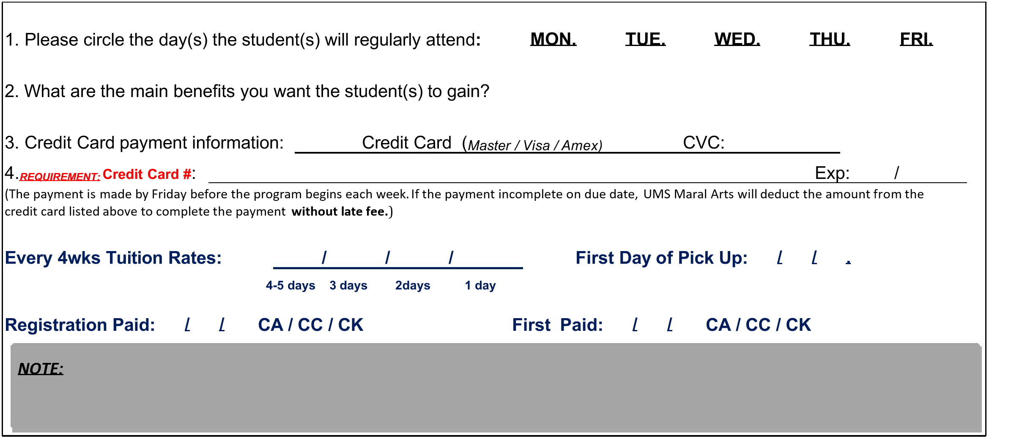
Student Information

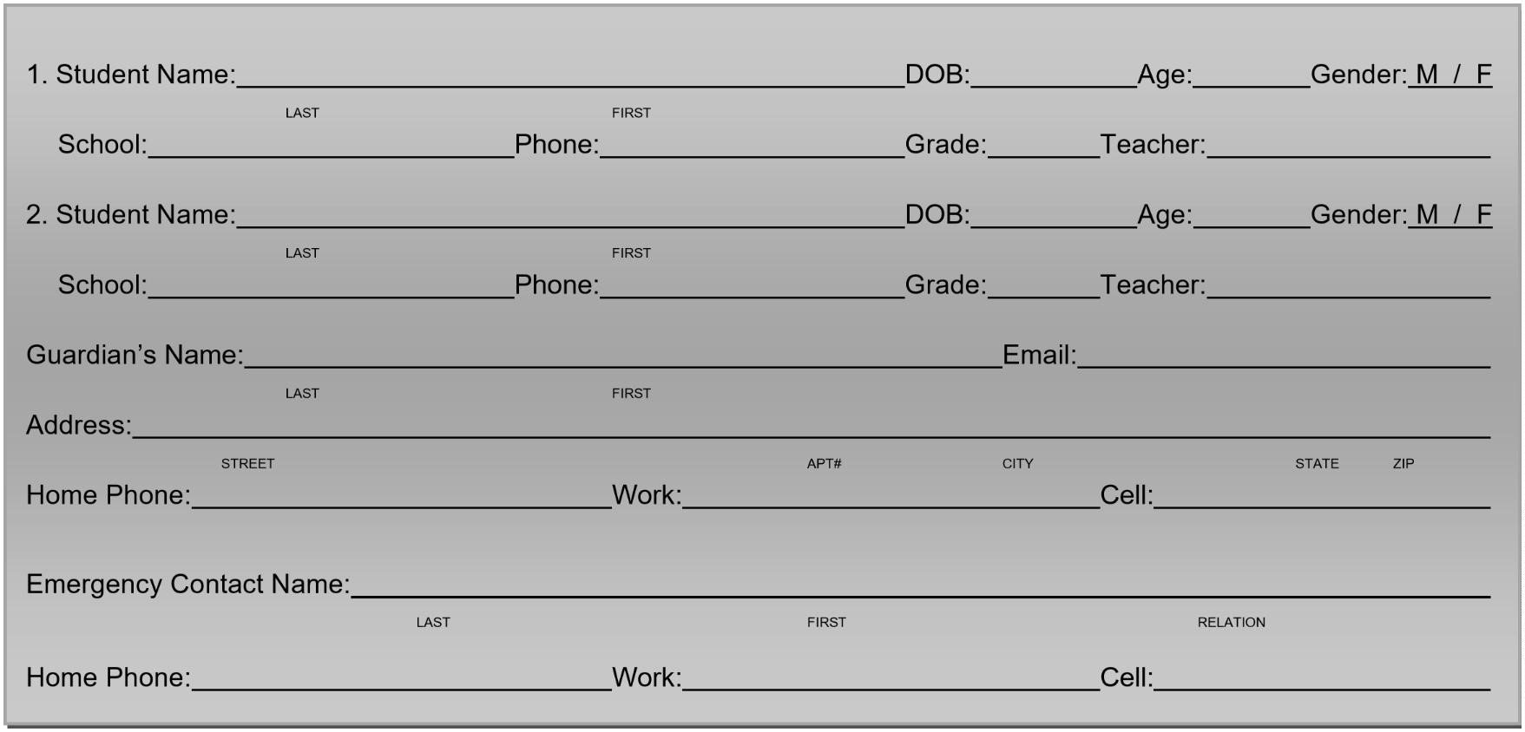

Program Information
Guardian’s Signature: ^{Date: __}
By signing above, I acknowledge and understand that I have read, understand, and agree to abide by the Terms and Conditions of this agreement.
Printed Name of Guardian: Registrar’s Initials __


UMS Martial Arts After School Waivers & Agreements
TERMS AND CONDITIONS – PLEASE READ

Payment Policy:
I agree to make payments in advance by Friday for the following 4 weeks. If I do not make a payment, I understand that UMS will not pick up the student(s) listed above. If I do not give UMS advance notice by the Friday before the following week that the student(s) do not need to be picked up, I agree to pay for that day. If payment is not made by Friday before the program begins each 4 weeks, I authorize UMS Maral Arts to deduct the amount from the credit card listed above, and if the payment cannot be deducted, I agree to pay the $10 late fee within five business days. If payment is declined (i.e., card), there will also be a $15 fee, along with a $15 bounced check fee if the check is found invalid. I understand that if payments are not made by me, UMS will refer the issue to a collection agency. I agree to pay the $25 service charge to UMS for any checks returned to UMS Maral Arts.

Cancellation Policy:
Cancellation must be in writing by email to umsmaralarts@gmail.com. Two weeks’ notice must be given to cancel at any time.

Pick-Up Policy 1:
I will notify UMS Maral Arts if the student(s) will not need to be picked up from school or if another person is to pick up the student(s) from UMS Maral Arts. If I or the person designated to pick up the student(s) from UMS Maral Arts is late picking up the student(s), I agree to pay the late fee associated with the pick-up time by the Friday of the week the charges were incurred: $10 charged for each 15-minute time block starting at 6:00 PM.

Pick-Up Policy 2:
Please come to the front desk and let us know you are picking up your child. We will walkie-talkie to UMS staff to call your child to the front. Parents are not allowed to enter the after-school room without permission. If someone other than the parents or guardian is picking up your child, please call the office at 703-914-1110 and send an email to umsmaralarts@gmail.com or send a note.

Schedule Change:
You can change the pick-up schedule temporarily. The change of note, email letter, or text to 703-914-1110 should be submitted by Friday for the following week. There will be no credit for the change of attendance. There will be no additional fee for the change of schedule if you notify UMS Maral Arts by the Friday before the week you want to change the schedule. You may have to pay additional tuition in the case of additional attendance caused by the change of schedule.

No Call, Text, Email / No Show:
Please notify us by noon in case of emergency that your child will not ride the UMS Maral Arts vehicle. UMS will not refund or give credit to parents if the student does not show or is absent. You will be responsible for the No Call, Text, Email / No Show fee of $10 for failure to notify in a timely manner. Please understand that your failure to notify affects pick-up procedure.

Additional Costs:
I understand and agree that there will be special events held at the school, including but not limited to belt tests, tournaments, camps, etc., and these events may incur additional fees beyond the amounts set forth in this agreement. I also understand and agree that the cost of additional uniforms, equipment, etc., is not included and must be purchased separately.

Advertising Policy:
I hereby authorize UMS Maral Arts and its directors and personnel to photograph me and/or the student(s) and/or use our voice, and to utilize such photographs, video footage, and/or voice transcriptions for commercial purposes, including but not limited to the promotion and marketing of UMS Maral Arts. I agree that I, nor any party acting on my or the student(s)’s behalf, shall be entitled to receive any compensation whatsoever of any kind because of such use.

Personal Property Policy:
I understand and agree that UMS Maral Arts’ employees and directors shall not be held responsible for any personal property which is damaged, lost, or stolen in or around UMS Maral Arts or its facilities, or at any of UMS Maral Arts’ off-premises events and field trips.

Waiver and Release:
I, as the student(s)’s legal guardian, fully recognize that martial arts involve strenuous physical exercise and I am fully aware of the risks of injury and/or illness inherent in participation in any fitness or martial arts program, and I have taken all reasonable steps to determine, and hereby warrant, that the student(s) is(are) in good health and physically capable of participating in the programs and courses of instruction offered by UMS Maral Arts. I understand and agree that all participation in any such fitness program or use of UMS Maral Arts’ equipment or facilities on or off the premises, including field trips, shall be at our own risk. UMS-held events such as summer camp, winter camp, spring camp, day camp, Parents’ Night, birthday parties, Taekwondo championships, etc., shall also be at your own risk.

I authorize the personnel of UMS Maral Arts to transport the student(s) to and from UMS Maral Arts in any event. I hereby release, indemnify, and hold harmless UMS Maral Arts and its directors and employees from and against all claims, demands, damages, costs, and liabilities of any kind or nature, including attorney’s fees and costs, for any injury, harm, or fatalities of myself or the student(s), or of any person(s) who become entitled to the use of the facilities of UMS Maral Arts by virtue of this agreement, or any third persons, which arise directly or indirectly out of or in virtue of our presence at UMS Maral Arts.

In the case of a medical emergency, I authorize UMS Maral Arts to seek medical attention for the student(s) listed above, and I authorize the attending physician to perform any emergency treatment deemed necessary. I hereby grant permission for my child to be transported by UMS Maral Arts for activities. I understand that notice of such outings will be given prior to any trip. In case of a medical emergency, every effort will be made to contact me or my emergency contact. If I, or someone on the emergency form, cannot be reached, I give UMS Maral Arts permission to secure the medical treatment necessary for my child, including hospitalization.

I understand that UMS Maral Arts assumes no responsibility for injuries or illnesses which my child may sustain as a result of his/her physical condition or resulting from participation in any athletic activities, sports programs, field trips (including but not limited to the pool, movie theatre, embassy, Chuck E. Cheese, etc.), transportation, use of equipment, exercise, or other activities. I expressly acknowledge on behalf of myself and my heirs that I assume the risk for any and all injuries and illnesses which may result from participation in these activities and I hereby release and discharge UMS Maral Arts, its agents, and employees from any and all claims for injury, illness, death, or loss or damage of property which my child may suffer as a result of participation in these activities. I understand that UMS Maral Arts is not responsible for personal property lost or stolen while members and/or program participants are using UMS Maral Arts facilities or premises.

This signed document can be used in lieu of a separate liability or registration signature for any other UMS Maral Arts activities, allowing participation in these programs (including but not limited to day camp, Parents’ Night, and future events after 2025).

By signing below, I acknowledge that I have read, understood and agreed to the terms and condition presented above

Guardian’s Signature: _____________________________________________________Date: _______________

